**SHIBLY MOHAMMAD NOMAN**

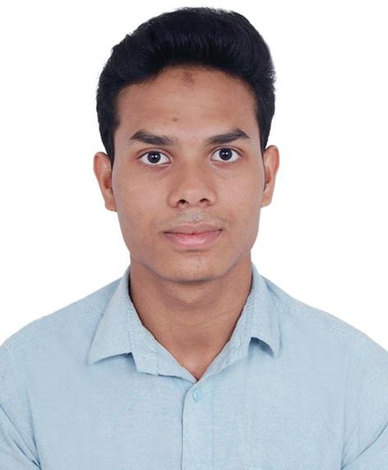

**Address:** 40/1, Moneswer Road, Zigatola, Dhanmondi, Dhaka-1209

**Contact:** (+880) 1307609911

**Email:** [shiblynoman20@gmail.com](mailto:shiblynoman20@gmail.com)

**Linkedin:** https://bit.ly/shibly_noman_linkedin

# Objective

Ultimate goal is to establish myself as a good human being, who enjoys and is passionate about his work.

# Personal Skills and Competencies

* Enthusiastic about learning.
* Capable of effectively communicating at various levels with individuals and groups.
* Have a solid concept in Object-Oriented Programming.
* Efficient with javascript, PHP, and MySql.
* Familiar with p5.js, python, django framework, and Git.
* Have a strong concept about API.
* Have a sound knowledge about Software development processes and Database.
* Capable of making effective use of search engine and other internet resources.

# Employment History:

**Interconnection Limited,** Dhanmondi, Dhaka

*Testing and Support Engineer. (Full Time)*

April 2019 – Till Date

* Hands-on experience in django framework and organizational database design and development process.
* I train our customer and do the necessary networking, hardware and software troubleshooting to ensure the environment to use our software.
* Recruit, train, and manage the data entry team.
* Get the work done by deploying the data entry team effectively.

**Duranta Developer BD,** Niketon, Gulshan, Dhaka

*Junior Testing and QA Engineer. (Part Time)*

February 2017 - September 2018

* Had the chance to introduce myself to the commercial software development process.
* Had hands-on experience in Javascript, PHP, and MySql.
* Developed documentation and necessary diagrams for new projects.
* Collaborated with the developer team to ensure software quality.

**Tech Giant BD,** Dhanmondi, Dhaka

*Marketing Communication Executive.(Part Time)*

October 2015 - December 2016

* Created and maintained digital marketing content.
* Maintained the company’s website and wrote blogs.

# Extracurricular Activities:

* Volunteer in *BASIS seminar at Institute of Science and Technology, 2017*.
* Attained the post of *Patrol Leader of the college scout unit, 2014.*
* Participated in *intercollegiate debate competition, 2014.*

# Education

**Bachelor of Science in Computer Science and Engineering, (Cont.)**

Institute of Science and Technology Result: (Cont.)

# Higher School Certificate (Science), 2014

Dania University College Result: 4.30

# Secondary School Certificate (Science), 2012

Dabir Uddin Bhuyan High School Result: 4.63

# Reference

**K. M. Muntasir Billah Munna**

Senior Engineer, R&D  
bKash Limited

Email: [kmmuntasir@gmail.com](mailto:kmmuntasir@gmail.com) Cell no: 01516180603